## Agile vs. scrum

People often think scrum and agile are the same thing because scrum is centred around continuous improvement, which is a core principle of agile. However, scrum is a framework for getting work done, whereas [agile](https://www.atlassian.com/agile) is a philosophy. The agile philosophy centres around continuous incremental improvement through small and frequent releases. it takes dedication from the whole team to change the way they think about delivering value to your customers. But you can use a framework like scrum to help you start thinking that way and to practise building agile principles into your everyday communication and work.

The difference between agile and the definition of scrum can be found in the Scrum guide and the [Agile manifesto](https://www.atlassian.com/agile/manifesto). The Agile manifesto outlines four values:

* Individuals and interactions over processes and tools
* Working software over comprehensive documentation
* Customer collaboration over contract negotiation
* Responding to change over following a plan

The definition of scrum is based on empiricism and lean thinking. Empiricism says that knowledge comes from experience and that decisions are made based on what is observed. Lean thinking reduces waste and focuses on essentials. The scrum framework is heuristic; it’s based on continuous learning and adjustment to fluctuating factors. It acknowledges that the team doesn’t know everything at the start of a project and will evolve through experience. Scrum is structured to help teams naturally adapt to changing conditions and user requirements, with re-prioritization built into the process and short release cycles so your team can constantly learn and improve.

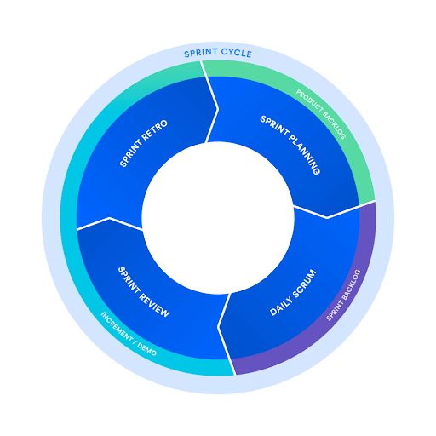

## The scrum framework

The scrum framework outlines a set of values, principles, and practices that scrum teams follow to deliver a product or service. It details the members of a scrum team and their accountabilities, “artefacts” that define the product and work to create the product, and scrum ceremonies that guide the scrum team through work.

## Members of a scrum team

A scrum team is a small and nimble team dedicated to delivering committed product increments. A scrum team’s size is typically small, at around 10 people, but it’s large enough to complete a substantial amount of work within a sprint. A scrum team needs three specific roles: product owner, scrum master, and the development team. And because scrum teams are cross-functional, the development team includes testers, designers, UX specialists, and ops engineers in addition to developers.

### The scrum product owner

Product owners are the champions for their product. They are focused on understanding business, customer, and market requirements, then prioritizing the work to be done by the engineering team accordingly. Effective product owners:

* Build and manage the product backlog.
* Closely partner with the business and the team to ensure everyone understands the work items in the product backlog.
* Give the team clear guidance on which features to deliver next.
* Decide when to ship the product with a predisposition towards more frequent delivery.

### The scrum master

Scrum masters are the champions of scrum within their teams. They coach teams, product owners, and the business on the scrum process, and look for ways to fine-tune their practice of it. As the facilitator-in-chief, he/she schedules the needed resources (both human and logistical) for sprint planning, stand-up, sprint review, and the sprint retrospective.

### The scrum development team

Team members have differing skill sets, and cross-train each other so no one person becomes a bottleneck in the delivery of work. Strong scrum teams are self-organizing and approach their projects with a clear ‘we’ attitude. All members of the team help one another to ensure a successful sprint completion.

## Scrum artifacts

[Scrum artifacts](https://www.atlassian.com/agile/scrum/artifacts) are important information used by the scrum team that helps define the product and what work to be done to create the product.

**Product Backlog i**s the primary list of work that needs to get done and maintained by the product owner or product manager.

**Sprint Backlog** is the list of items, [user stories](https://www.atlassian.com/agile/project-management/user-stories), or bug fixes, selected by the development team for implementation in the current sprint cycle.

**Increment** (or Sprint Goal) is the usable end-product from a sprint. we usually demonstrate the “increment” during the end-of-sprint demo, where the team shows what was completed in the sprint. You may not hear the word “increment” out in the world, as it’s often referred to as the team’s definition of “Done”

## **Scrum ceremonies**

The scrum framework includes scrum practices, ceremonies, and meetings that scrum teams perform on a regular basis. The [agile ceremonies](https://www.atlassian.com/agile/scrum/ceremonies) are where we see the most variations for teams.

1. **Organize the backlog:** Sometimes known as backlog grooming, this event is the responsibility of the product owner.
2. **Sprint planning:** The work to be performed (scope) during the current [sprint](https://confluence.atlassian.com/agile/glossary/sprint) is planned during this meeting by the entire development team. This meeting is led by the scrum master and is where the team decides on the sprint goal.
3. **Sprint:** A sprint is the actual time period when the scrum team works together to finish an increment. Two weeks is a pretty typical length for a sprint, though some teams find a week to be easier to scope or a month to be easier to deliver a valuable increment.
4. **Daily scrum or stand up**: This is a daily super-short meeting that happens at the same time (usually mornings) and a place to keep it simple. Many teams try to complete the meeting in 15 minutes, but that’s just a guideline. This meeting is also called a ‘daily stand-up’ emphasizing that it needs to be a quick one.
5. **Sprint review**: At the end of the sprint, the team gets together for an informal session to view a demo of, or inspect, the increment. The development team showcases the backlog items that are now ‘Done’ to stakeholders and teammates for feedback.
6. **Sprint retrospective:** The [retrospective](https://www.atlassian.com/agile/scrum/retrospectives) is where the team comes together to document and discuss what worked and what didn’t work in a sprint, a project, people or relationships, tools, or even for certain ceremonies. The idea is to create a place where the team can focus on what went well and what needs to be improved for the next time, and less about what went wrong.

**Link:**

[Scrum - What is it, how it works, & how to start (atlassian.com)](https://www.atlassian.com/agile/scrum#:~:text=People%20often%20think%20scrum%20and%20agile%20are%20the,getting%20work%20done%2C%20where%20agile%20is%20a%20mindset.)